Purpose / Scope:
Timing and action plan to capture lessons from projects, changes, problem solving, complaints and audits, prove their effectiveness and feed them into new projects. Standards: IATF 16949 7.1.6, 10.2.3, 10.3; VDA 6.3 P2.
Owner / involved:
- C. Demmler, Process Development: owner of PLM2 and of every action in this plan, author, keeps it current
- Program Management and APQP: support (specification, tests, pilots on the running projects, evidence)
- Departments named per action (IT, Quality, Development, Tooling, HR, department heads): support where their part is needed
- Plant Management: monthly status review
1. Summary
Lessons learned are built in PLM2 with owner, actions and a required effectiveness proof before closing. The SharePoint lessons list (LL-0001 to LL-0019, including ten G6X lessons) is already mirrored. The remaining step is to bind lessons into the processes: checked at SEP RG1/RG2, required at every change release and used as input to risk assessment. Procedure release is 01/04/2027.
2. Requirements and how they are met
Requirement | How it is met | What we show
Organisational knowledge (7.1.6) | Central lessons database, filtered by project, category, department and tag | Lessons board
Problem solving uses lessons learned (10.2.3) | Lessons carry root cause and recommendation and are linked to the change or project they come from | Lesson with change link
Continual improvement (10.3) | Status flow with actions; closing needs effectiveness note and verifier | Closed lesson
Lessons from previous projects used (VDA 6.3 P2) | Lessons check recorded per project and gate | Lesson reference on project 1994

3. Process flow
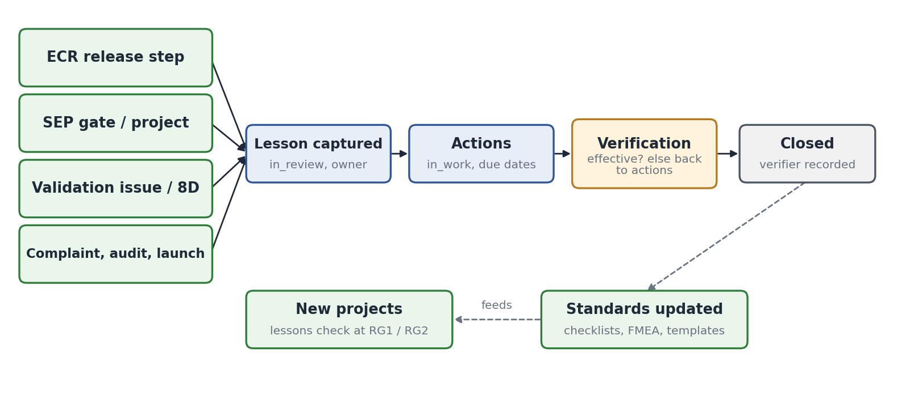
- Status: in review, in work, verification, closed (or rejected with category). A lesson cannot close while an action is open or without an effectiveness note.
- Stale lessons are flagged: 14 days in review, 7 days in verification; actions appear in the owner's task list.
- Closed lessons update standards (checklists, FMEA, templates) and are checked by the next projects at RG1 and RG2.
4. Where we stand today
Element | Status | Evidence in PLM2
Lessons with owner, actions, files, comments | Built | Lessons board and KPI board
Effectiveness proof and verifier before closing | Built | Close dialog
SharePoint list mirrored (LL-0001..0019) | Done | Live system, G6X lessons
Lessons step at change release | Built | Release tab of a change
Lessons check at SEP gates, input to risk / FMEA | Programming | Actions L2, L4

5. Tightening points
Today | Tightening measure | Action | Due
Lessons also kept in the SharePoint list | List frozen read-only; PLM2 only | L1 | 10/30/2026
Reuse in new projects is voluntary | Lessons check is a required SEP item at RG1 and RG2 | L2 | 11/27/2026
Release lessons step can be skipped for small changes | Lessons step required for every change release | L3 | 11/27/2026
Lessons not linked to risk assessment | Relevant lessons listed in the project risk assessment | L4 | 12/11/2026

6. Timing and action plan
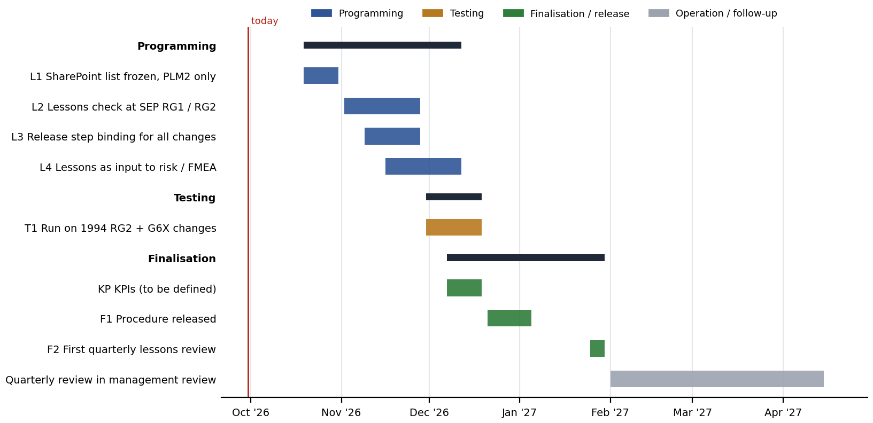
No. | Action | Phase | Owner | Support | Due | Done when
L1 | SharePoint lessons list frozen read-only; PLM2 only | Programming | C. Demmler | Program Mgmt., APQP | 10/30/2026 | List locked
L2 | Lessons check as required SEP item at RG1 / RG2 | Programming | C. Demmler | Program Mgmt., APQP | 11/27/2026 | Item enforced in SEP
L3 | Lessons step required at every change release | Programming | C. Demmler | Program Mgmt., APQP | 11/27/2026 | Release blocked in test
L4 | Relevant lessons shown in project risk assessment | Programming | C. Demmler | Quality | 12/11/2026 | Risk form shows lessons
T1 | Run on 1994 RG2 and the G6X changes | Testing | C. Demmler | Program Mgmt., APQP | 12/18/2026 | References recorded
KP | KPIs (open, to be defined): set targets, sources and review cycle for lessons learned, starting with lesson actions implemented on time | Finalisation | C. Demmler | Quality, Program Mgmt. | 12/18/2026 | KPI set agreed, shown in the monthly review
F1 | Procedure 'Lessons learned in PLM2' released | Finalisation | C. Demmler | Quality | 01/04/2027 | Procedure in document control
F2 | First quarterly lessons review in management review | Finalisation | C. Demmler | Plant Mgmt. | 01/29/2027 | Minutes filed

The table is the plan as of the status date above. Progress is tracked in the action plan TOC-PLM-LOP (KTX LOP F-DVS-CORP-010); a date that moves is changed there with the reason, and this document is updated with it.
7. Control until go-live
Lessons are captured in PLM2 from now on. The SharePoint list stays readable as history until it is frozen (L1).
8. Effectiveness indicators
Indicator | Target | Source
Lessons closed with effectiveness proof | 100 % | Lessons KPI board
New projects with lessons check at RG1 / RG2 | 100 % | SEP matrix
Lessons stale beyond flag limits | 0 at monthly review | Lessons KPI board
Lesson actions implemented on time (due date met) | To be defined (action KP) | Lessons KPI board, due vs closed date

The KPI set beyond these indicators is to be defined (action KP): targets, data source in PLM2 and the review cycle are agreed with Quality and Program Management before the procedure is released.

